N.W OHIO SWIM LEAGUE FALL MEETING
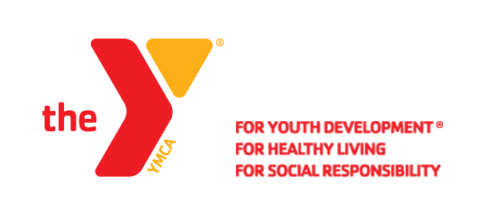
SEPTEMBER 13TH, 2016 10:00AM
GEARY FAMILY YMCA
MEETING MINUTES

1. Mary Fuller
- Devotion
2. Introduction of attendees
- YMCA’s in attendance
- Francis Family, Fort Meigs, Monroe, Toledo, Galion, Lima, Putnam, Defiance, Tiffin, Wolf Creek, Williams,VanWert, Hardin, Fostoria
3. Passed around roster to update
4. May Minutes were approved
-Molly from Tiffin started the motion
-Katelyn from Defiance 2nd
5. Dave Stannert discussed the changing of events to champs.
-500’s were moved around
-4 Events Max Per Day, 6 Events Max for the whole weekend
-League agreed these were good
6. Zone Report – Amanada and Dave
-Register Team on the website, $50.00 fee by credit card only
-Teams should think about paying these now, use it to get used to the website.
-Coaches need to be registered on the website as well
-Coaches credentials cards are not issued unless requested
-CPR uses completion of cert date, not expiration date
-CPR must be renewed every year, even if it is a 2 year cert
-If you have lifeguarding you must have STFSC too
-To apply for a sanctioned meet, it is $60.00
7. Swimposium
-October 1th-16th in Columbus
-Flyer was passed around
8. League Meet Schedules
-Do not cancel dual meets due to weather, other teams need those meets
-Must have 3 YMCA swim meets complete to compete in champs
-Invitationals and Dual Meets can count towards the 3
-All YMCA’s should support others invitationals
-Meets Moved: 02/11 Van Wert&Williams @ Definace
-Meets Moved: 01/07 Lima @ Van Wert
-New Schedule to be sent as it is updated
-Shelby YMCA is to be removed from our schedules, they are losing there charter.
-If Shelby is in good standing, they may be added to a meet as a Tri (detail to come)
9. Information from Jodi Clute
-Swim Team & Coach Info sheet passed around
-Annual Registration
-Resource info
-Virtual Meet
10. Official Training
-Level 1 & 2 @ Wapak – October 1st
11. Upcoming Invitaitonals
-Fall Sprint Meet: November 5th
-Galion Lil Fins: November 5th
12. Set Date and Time for Spring Meeting
-May 16th 10:00am Geary Family YMCA – Fostoria
13. Champs entries due Wednesday, February 22nd
14. Fitter Faster @ Defiance October 8th – Spots still open
15. Molly Lofton – Swim Lesson Training

